Student Name (full): Student # ________________
Teacher: _______________ Class: __________ Period: ____Grade: __ _ Date: __________

DREAM CAREERS:
Before you start myBlueprint note below careers that you are considering for your future. (identify at least 1 career choice - 3 careers if you can’t decide)

1.
2.
3.

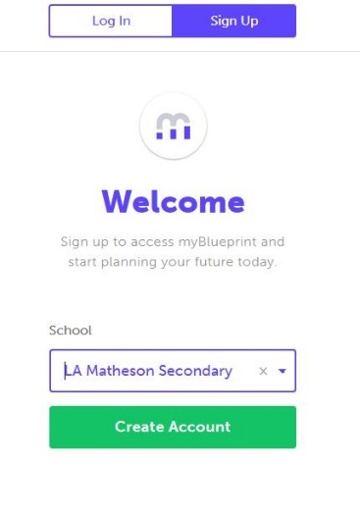
CREATE YOUR ACCOUNT

1. Open Internet Explorer or google chrome
URL: https://www.myblueprint.ca/sd36
Start myBlueprint

- Select “Sign Up” at the top of Page
- Select “LA Matheson” in drop down list
OR ENTER ACTIVATION KEY - LAMATHESON
- Click Create Account
Setting up your Account

- Select your grade & Click Continue
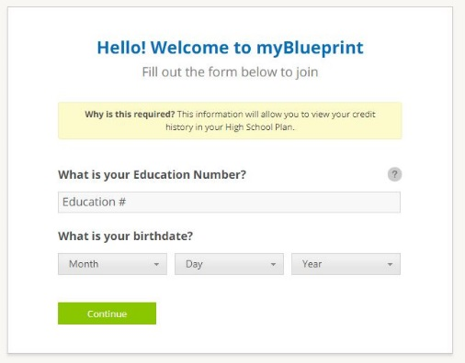
- Complete and “Click Continue”
YOU MUST GIVE PEN # &
BIRTHDATE

YOUR PEN # IS IN MYED

- Complete information and click Create Your Account
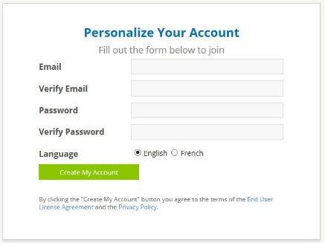
- SAVE YOUR ACCOUNT INFO IN YOUR PHONE

- GO TO YOUR EMAIL AND VERIFY YOUR MYBLUEPRINT ACCOUNT

STUDENT ACCOUNT

STEP 1 – Review the Key Features of My Blueprint:

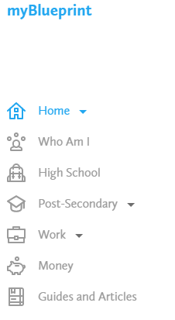
WHO AM I: A comprehensive bundle of 6 different assessments designed to support you in the process of self-discovery and exploration. Who Am I includes interactive surveys for Learning Styles, Myers-Briggs Personality Types, Holland Interest Themes, Knowledge, Motivations and Compatibility.

GOALS: Allows you to create S.M.A.R.T. goals and track your progress towards achieving your goals.

RESUME & COVER LETTER: A simple, easy-to-use resume and cover letter builder for you. This allows you to keep track of your experiences.

HIGH SCHOOL: The High School Planner is where you can plan courses and track your progress toward graduation. You can also see your eligibility for Post-Secondary education across Canada – University, College, Workplace, and Apprenticeship.

POST-SECONDARY: Allows you to research all of the post-secondary programs available to you across Canada. You can select your preferred pathway, and use filters to narrow down programs of interest.

OCCUPATIONS: Allows you to research various occupations and details related to the occupation, including main duties, important skill sets, and the post-secondary pathway that you should take to get into your career of choice.

JOB SEARCH: Allows you to search real-world job postings from Indeed.ca that relate to occupations of interest.

MONEY: Allows you to create budgets and financially plan for post-secondary.

PORTFOLIOS: Allows you to create multiple e-portfolios and share it with parents, teachers, or future employers. This will be used in your classes and for your ultimate CAPSTONE PORTFOLIO presented before graduation

Review How to Complete Activities and Earn Points:

There are grade-specific activities that students can complete on myBlueprint. Students can find the list of suggested activities for their current grade in the Activities tab of the Home section.
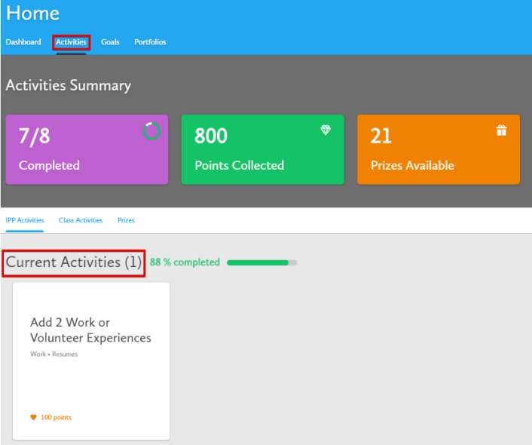
- Students can keep track of their activity completion progress using the Activities Summary overview. Teachers can also keep track of students’ activity progress from their teacher account.

- Students can click on the Current Activity boxes to start any of the activities.

- When students complete an activity, they will earn Points. Students can keep track of the points they have collected so far.

- Students can use their points to enter into Prize Draws by clicking the Prizes tab

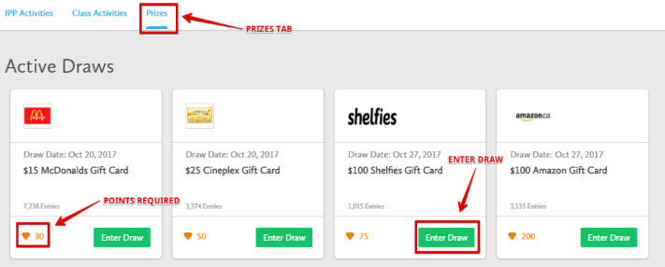
- Each Active Draw has a required number of points needed to enter.

- Students can enter as many times as they wish!
- Students can enter a draw by clicking the Enter Draw button.

ASSESSMENTS

STEP 2 – Complete the “Who Am I” Assessments
- Learning Styles
- Personality
- Interests
- Knowledge
- Motivations
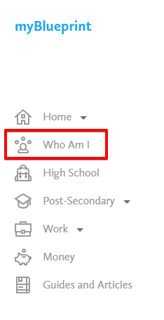
- Compatibility

- There are 6 Comprehensive Assessments
Click on “Who Am I” and Choose the top survey and more to complete
(As you grow and change so do your results. Retake surveys in different grades)
Complete all 6 Assessments by Grade. 10.
- You will be matched with occupations starting from the Interests Assessments. Your occupation matches become more refined as you complete more assessments. COMPLETE AS MANY COMPATABILITY ASSESSMENTS AS YOU CAN!
- To access the Assessments, you can click the Who Am I Tab
from the Navigation Menu on the left hand side.
- You can also search occupations that you are interested in outside of the suggestions via the Occupations tab.

- What is your learning style? Do you agree or disagree? Explain.

__________________________________________________________

What are two of the suggested study tips that you think will help you?
_____________________________________________________________________________________
_____________________________________________________________________________________

- What is your personality type? Do you agree or disagree? Explain.

_____________________________________________________________________________________
_____________________________________________________________________________________

- What is your interest type? Do you agree with the description of your interest type? Explain.

_____________________________________________________________________________________
_____________________________________________________________________________________

What are your primary and secondary interest traits? ________________ _________________
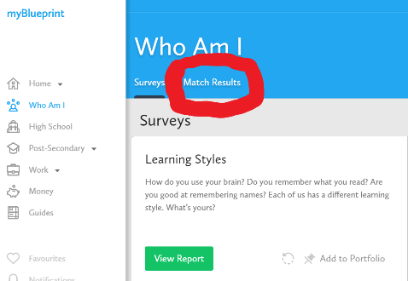
What are three of the occupation matches listed in the Match Results tab?
Would you enjoy these careers? Why or why not? Explain.
(*HINT: Complete the Compatibility Survey by clicking ‘Get Started’ to learn more about an occupation)
Occupation 1.
__________________________________________________________ Occupation 2. __________________________________________________________
Occupation 3.
_______________________________________________________________________________________________
What do these occupation matches have in common with your interest traits (Click View Report and read about your top two interest traits)?
__________________________________________________________________________________________________________________________________________________________________________

ASSESSMENTS Continued

4.) What are your Knowledge Results? Once knowledge survey completed, click View Report and answer the following questions.

What are your top three subject areas?
1. __________________________________
2. __________________________________
3. __________________________________

What topics do they include?
1. ___________________________________________________________________________________
2. ___________________________________________________________________________________
3. ___________________________________________________________________________________

What is your Career Cluster?
____________________________________________

What are some of the things someone in this career cluster would enjoy? Is it suited to your interests?
__________________________________________________________________________________________________________________________________________________________________________
What are three of the occupation matches listed at the bottom of the page? Would you enjoy these careers? Why or why not? Explain.
(*HINT: Complete the Compatibility Survey by clicking ‘Get Started’ to learn more about an occupation)
Occupation 1. ____________________________________________________________________________
Occupation 2. ____________________________________________________________________________
Occupation 3. ____________________________________________________________________________
Which one of the following categories would you classify your motivation under? Circle the ones that apply to your previous answer.

Recognition | Achievement | Working Conditions
Support | Relationships | Independence
5.) Once Motivations Survey completed, click View Full Report and answer the following questions
What are your top two motivation factors?
1. __________________________________
2. __________________________________
How do your results compare to your own perception of motivation factors from your answers above? _______________________________________________________________________________________________
_______________________________________________________________________________________________
How will understanding your top motivation factors help you pick a career?
_______________________________________________________________________________________________
_______________________________________________________________________________________________
PORTFOLIOS

STEP 3 – Create a Portfolio
Click on the “Portfolio” Tab and then “+ Add Portfolio”

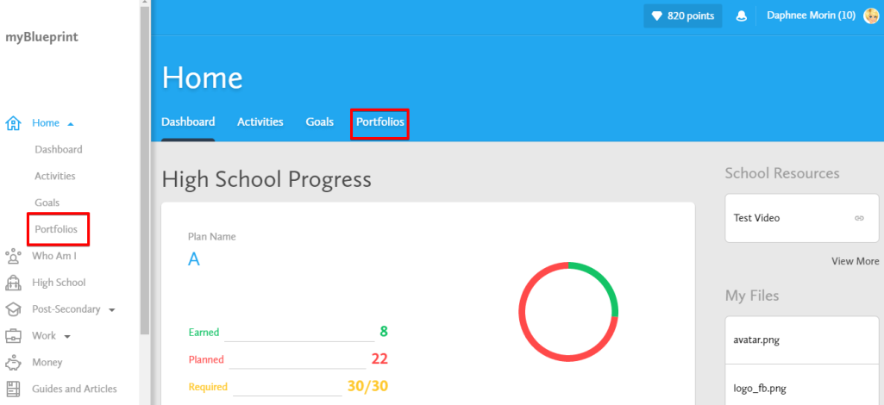
At any time, you can create multiple portfolios, and can choose what elements you want your portfolio to display.

To begin, select Portfolios or click on the Portfolios Tab in the Home section in the navigation Menu.

Students can personalize their portfolio by adding a Banner Image and an Avatar
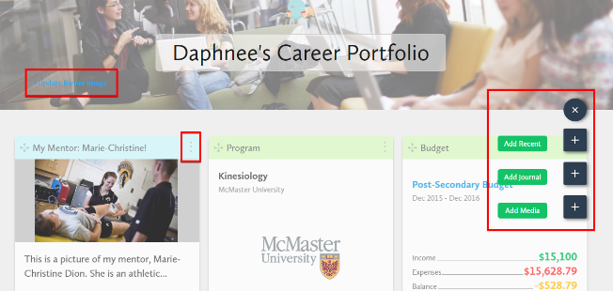
To add a box (artifact) to a portfolio, click on + Add Box and select one of the three options: Recent, Journal, or Media.
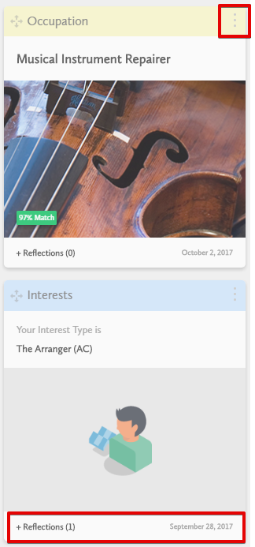
- Recent: Choose the activities from their myBlueprint account to be included in the portfolio.

- Journal: Enter a journal entry and attach a file, picture, video, or link.

- Media: Students may also upload external files (pictures and documents) or embed a video (by copying and pasting the link from a hosting site) to add to their portfolio. Students can also add a website link (URL) to their portfolio.

- At any time, students can add multiple reflections for the element (artifact) they have included in their portfolio. Each reflection will be date stamped. To add a reflection, click on the + Reflections (0) button at the bottom right of the artifact you added to your portfolio.

- Students can share their portfolio with you via email or by downloading it as a PDF.
- Students can edit the content, delete, move, or change the colour of their artifacts by clicking the three dots at the top right of the artifact.

PORTFOLIOS
- Select Home from the menu navigation on the left hand side of the screen and click on the fourth tab on the main home page called Portfolios
- Click + Add Portfolio
- Name your Portfolio ‘Career Portfolio’
- Add the following boxes (artifacts) and corresponding reflections to your portfolio by clicking + Add Box, then Add Recent +
  - Your learning style survey report- Were you surprised at the result? Why or why not? What study tips did you learn?
  - The 2 post-secondary opportunities you’ve added to your favourites in the Post-Secondary- Why did you choose these two opportunities? What did you like? Dislike?
  - The 2 occupations that you’ve added to your favourites in the Occupation Plan - Why did you choose these two occupations? Did they match your learning style and what did you learn from that? What do you find interesting?
  - The goal you’ve created - Why did you choose to create this goal? What resources do you have to help you reach this goal?

- Write a short (50-100 word) journal entry on one of the following topics by selecting + Add Box and Add Journal + :
  - What steps you will take in the next year to plan for the future:

GOAL SETTING
- Select Home from the menu navigation on the left hand side of the screen
- Select the Goals tab and click + Add Goal
- It must be a S.M.A.R.T. Goal
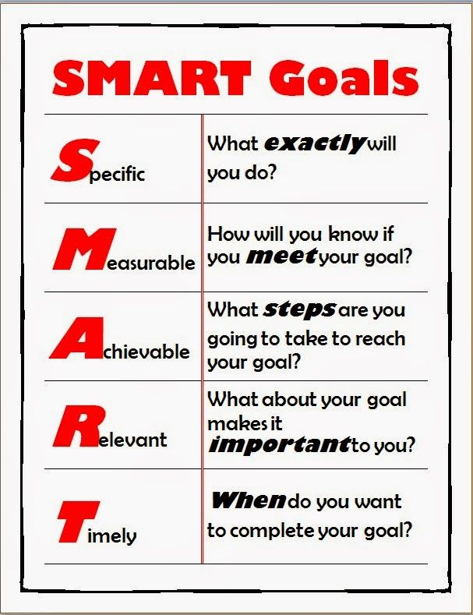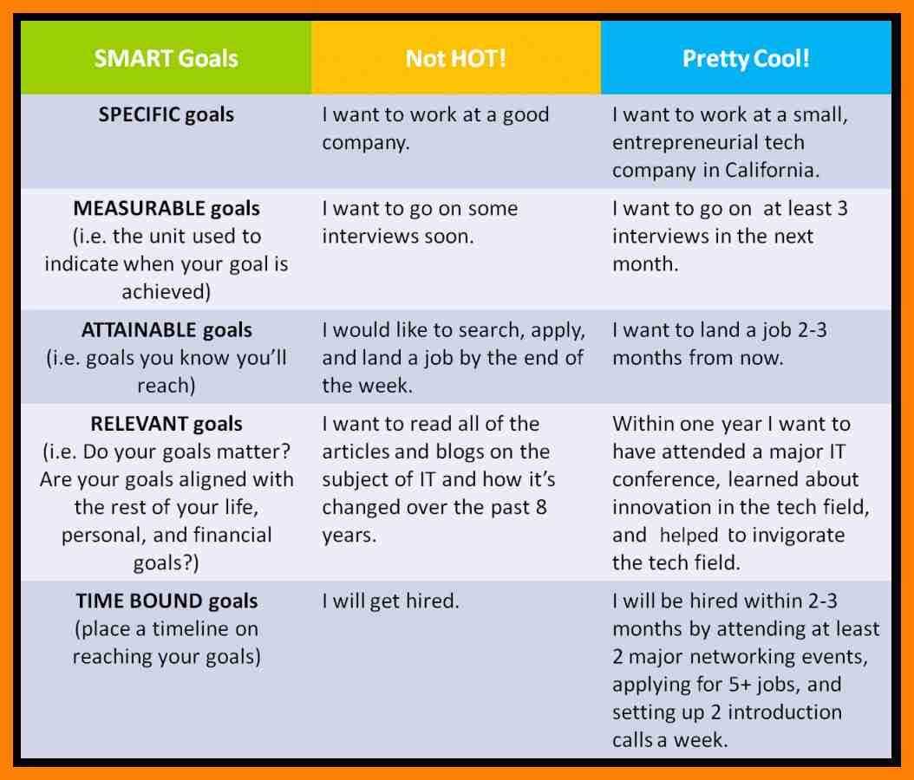

- Add ONE (1) Goal and include an Action Plan for how you intend to achieve it
- Add as many additional goals as you’d like
WHAT IS ONE (1) OF YOUR GOALS?
______________________________________________________________________________________________________________________________________________________________________________________________
POST-SECONDARY AND OCCUPATION PLANNING: TRY BOTH
- Select Post-Secondary from the menu navigation on the left hand side of the screen
- To plan starting with Post-Secondary, choose a pathway option from the dropdown list (e.g. Apprenticeships, College or University)
- Pick TWO (2) opportunities that interest you and favourite them by clicking the heart beside it
All of your favourited post-secondary opportunities and occupations will be saved in the Favourites section, located in the menu navigation on the right hand side of the screen
WHAT ARE THE NAMES OF TWO (2) POST- SECONDARY OPPORTUNITIES YOU FAVOURITED?
____________________________________________________________________

- To plan starting with Occupations, choose Work from the menu navigation on the left hand side of the screen and then select Occupations. Enter Occupation Name or Keyword in the search bar and click Search when you are ready.
- Pick TWO (2) opportunities that interest you and favourite them by clicking the heart beside it
WHAT ARE THE NAMES OF TWO (2) OCCUPATION OPPORTUNITIES YOU FAVOURITED?
____________________________________________________________________

COMPATABILITY
- Select Who Am I from the navigation menu on the left hand side of the screen
- Select the Match Results Tab and complete 2 Compatibility Surveys by clicking Start Survey to the right of the Occupation Matches
What two occupation matches did you choose?

1. ____________________________ 2. _____________________________

What was your percentage of compatibility for each occupation?

1. ____________________________ 2. _____________________________

Are either of these careers of interest to you? YES NO MAYBE
EXPLAIN:_______________________________________________________________________________________________________________________________________________________________________
_______________________________________________________________________________________

Select the occupation with the highest compatibility score, and answer the following questions:

Based on the results of your Interests assessment, do you think that this career is a good match? Why or why not?
_____________________________________________________________________________________________________________________________________________________________________________________________________________________________________________________________________
Based on the results of your Knowledge assessment, do you think that this career is a good match? Why or why not?
_____________________________________________________________________________________________________________________________________________________________________________________________________________________________________________________________________
Based on the results of your Motivations assessment, do you think that this career is a good match? Why or why not?
_____________________________________________________________________________________________________________________________________________________________________________________________________________________________________________________________________

